SUBJECT 1`

1. The semantics of propositional logic.

Using a semantic proof method, prove that the syllogism rule is a tautology.

1. Check the distributivity property of the existential quantifier over implication using a syntactic proof method. The theorem of soundness and completeness of the method.

1. Draw a logic circuit having 3 inputs and containing all basic and derived gates. Write the corresponding Boolean function and simplify it. Draw the simplified circuit.

SUBJECT 2

1. Using lock resolution check whether this deduction holds: .

Resolution as a formal system.

1. Using a semantic proof method check if the formula: 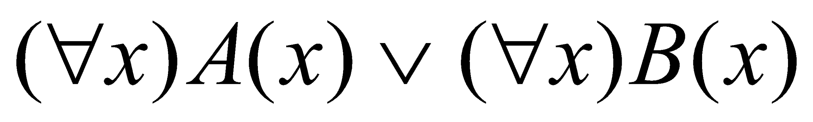 is a logical consequence of the formula: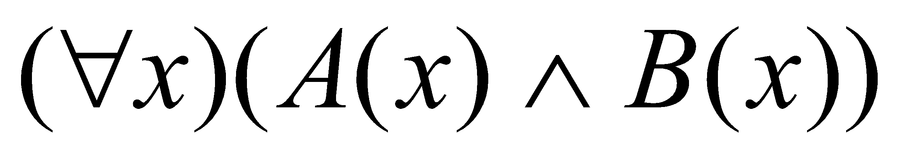. Theory.
2. Simplify the following Boolean function using Veitch diagram:  Implement the logic circuits corresponding to the initial form of *f* and to all the simplified forms of *f*.

SUBJECT 3

1. The formal (axiomatic) system of propositional logic. What is a theorem?

Using a refutation proof method prove that the separation of the premises law is

a theorem.

2. Evaluate the formula U= under two

interpretations: one with a finite domain and the other with an infinite domain. How many

possible interpretations has U? Is predicate logic decidable? Justify your answer.

1. Using Quine’s method simplify the Boolean function:

.

Implement the logic circuit associated to a simplified form of *f*.

SUBJECT 4

1. Write all the models and the anti-models of the formula: V=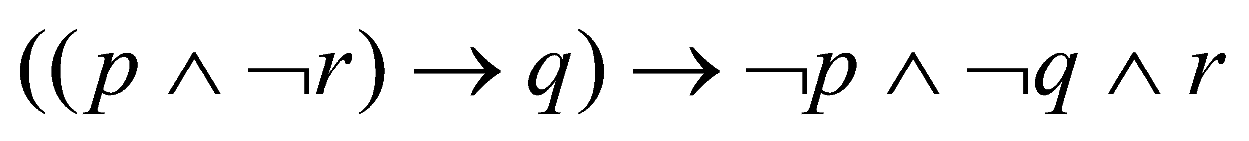.

Theory.

2. Using linear resolution check whether the following set of formulas is inconsistent.

. Theory.

3. Definitions for: minterm, maxterm, central monom, maximal monom, factorization.

Examples of 4 minterms and 4 maxterms of 4 variables: expressions, notations and tables

of values. Draw the logic circuit associated to the Boolean function:

.